Epsom & Ewell F.C.
14
v
Cove F.C.
Tuesday, 8th December 2015 – 7.45pm
Good evening! We welcome the players, supporters and officials of Cove Football Club, together with today’s match officials and our own regular supporters.

It is hard not to sympathise with the plight of our opponents. After being title challengers last term, they then had to witness many of their playing squad depart to Hartley Wintney where they now sit at the top of the league. Meanwhile, Cove currently cut a forlorn figure at the foot of the table, well adrift from all other clubs and facing an enormous challenge to stay up in the remainder of the season. We won there 7-0 in October when we got off to a flying start and just kept the pressure up and we have to be clinical again if we are to keep pace with the leaders ourselves. Of course we wish them well for the remainder of the season, once our match tonight is over!

On Saturday we hosted Guildford City and despite the blustery conditions we produced a near perfect performance, especially in the first half as we scored four times to blow the opposition away, and although the second half contained no further goals the damage had already been done and the opposition were well beaten by the end.

Following this evening’s match we travel to Ash United on Saturday where we face Badshot Lea. Then seven days later we will be back here for our League match with Sutton Common Rovers. The fixture situation is kind to us and we currently have just one midweek fixture left to play this season, which is our big League Cup last 16 match at home to Ashford Town (Mx) in January.

It is probably worth mentioning at this time that we only have one match over the Christmas period when we travel to Horley Town for a Monday morning kick off on December 28th. We then face Redhill here on Saturday 2nd January, so please put those dates in your diaries.

On the playing front we have a few new faces, although all four will be familiar to regular supporters. Carl Downs has been on the field recently, as has Steve Rowe, while Agi Panayiotou and also former Captain Jamie Hatfield have also returned to the club. This is just as well right now as we have a few injuries too. Hopefully James Taylor, Sam Currie and Dan Dean will be back soon and then Glyn and Matt can have a proper selection headache!

We thank one of our former players Marvin Hough for sponsoring tonight’s match. Most people know him as Kyle’s dad but he was with us back in the mid-seventies under Pat O’Connell and Arthur Evans. I should also point out that it is Kyle’s 28th birthday today, so we hope he will have some happy memories to celebrate it with.

Enjoy the game!

Rich

You can now follow us on Facebook www.facebook.com/epsomandewellfc or Twitter @EEFCOfficial

Cover Photos v Cove F.C. on 03/10/15 by Gemma Jarman

- Matt Farrell beats team mate Dan Dean to the loose ball to score our third goal
- Rob Hendry curls the ball into the top corner for our fourth goal of the match

Cherry Red Records Combined Counties League
Premier Division Table 2015/16
inc Saturday 5th December | P | W | D | L | F | A | Pts | GD | H | A
Hartley Wintney | 19 | 16 | 2 | 1 | 63 | 18 | 50 | +45 | 30/1 | 3-3
Ashford Town (Mx) | 19 | 14 | 1 | 4 | 45 | 24 | 43 | +21 | 30/4 | 3-2
Epsom & Ewell | 19 | 12 | 6 | 1 | 48 | 17 | 42 | +31 | X | X
Camberley Town | 17 | 12 | 3 | 2 | 33 | 14 | 39 | +19 | 16/4 | 20/2
Horley Town | 17 | 10 | 3 | 4 | 43 | 22 | 33 | +21 | 27/2 | 28/12
Hanworth Villa | 19 | 10 | 2 | 7 | 37 | 30 | 32 | +7 | 5-0 | 23/4
Colliers Wood United | 22 | 9 | 1 | 12 | 45 | 40 | 28 | +5 | 3-1 | 3-0
Spelthorne Sports | 19 | 8 | 3 | 8 | 35 | 39 | 27 | -4 | 16/1 | 6-2
Knaphill | 17 | 8 | 2 | 7 | 30 | 21 | 26 | +9 | 12/3 | 1-1
Windsor | 18 | 6 | 7 | 5 | 32 | 35 | 25 | -3 | 2-2 | 23/1
AFC Hayes | 20 | 7 | 4 | 9 | 29 | 33 | 25 | -4 | 1-1 | 9/1
Sutton Common Rovers | 19 | 7 | 3 | 9 | 36 | 37 | 24 | -1 | 19/12 | 2-1
Raynes Park Vale | 19 | 8 | 0 | 11 | 39 | 42 | 24 | -3 | 3-1 | 28/3
Westfield | 17 | 6 | 6 | 5 | 23 | 24 | 24 | -3 | 26/3 | 0-0
Chessington & Hook | 19 | 7 | 2 | 10 | 35 | 42 | 23 | -7 | 1-0 | 19/3
Guildford City | 20 | 7 | 2 | 11 | 39 | 50 | 23 | -11 | 4-0 | 2/4
Badshot Lea | 19 | 7 | 1 | 11 | 25 | 49 | 22 | -24 | 9/4 | 12/12
Farnham Town | 18 | 6 | 3 | 9 | 29 | 28 | 21 | +2 | 1-0 | 6/2
Chertsey Town | 19 | 4 | 5 | 10 | 16 | 30 | 17 | -14 | 0-1 | 5/3
Bedfont Sports | 18 | 3 | 7 | 8 | 23 | 27 | 16 | -4 | 13/2 | 2-2
Redhill | 17 | 3 | 3 | 11 | 23 | 40 | 12 | -17 | 2/1 | 1-0
Cove | 17 | 1 | 0 | 16 | 9 | 73 | 3 | -64 | 8/12 | 7-0

Lucky Day? – 8th December
Played 14 - W 9 D 1 L 4 - F 29 A 23 - PPG 2.00 - Very Good
Our Club record against Cove
Played 33 - W 14 D 9 L 10 - F 74 A 55 - PPG 1.59 - Above Average
Largest wins and losses against our opponent
3rd October 2015 - (A) W 7-0 - League - 27th April 2013 - (H) L 1-6 - League
Last visit
Saturday 7th March 2015 - D 2-2 - Combined Counties League

First Eleven Appearances - (max 23 – including Guildford City – 05/12/15)
Name | Debut | 2014/15 |  |  |  | Career Totals
 |  | App | Sub | Total | Goals | App | Sub | Total | Goals
AJAYI Tayo | 22/08/2015 | 0 | 2 | 2 | 0 | 0 | 2 | 2 | 0
COOPER-SMITH Daryl | 03/01/2015 | 15 | 4 | 19 | 8 | 24 | 7 | 31 | 14
CURRIE Sam | 04/08/2012 | 16 | 1 | 17 | 1 | 124 | 10 | 134 | 3
DAVISON Conor* | 22/08/2015 | 1 | 2 | 3 | 0 | 1 | 2 | 3 | 0
DEAN Dan | 02/08/2014 | 14 | 2 | 16 | 0 | 50 | 3 | 53 | 0
DOWNS Carl | 17/09/2011 | 1 | 1 | 2 | 0 | 95 | 14 | 109 | 2
EACOTT Michael | 02/08/2014 | 20 | 0 | 20 | 0 | 66 | 0 | 66 | 0
FARRELL Matt | 02/08/2014 | 22 | 0 | 22 | 5 | 63 | 3 | 66 | 12
FERDINANDO Matt | 20/09/2014 | 16 | 0 | 16 | 4 | 43 | 4 | 47 | 10
GRIFFIN Reisse | 08/08/2015 | 8 | 4 | 12 | 0 | 8 | 4 | 12 | 0
HASTINGS Craig | 08/08/2015 | 16 | 3 | 19 | 0 | 16 | 3 | 19 | 0
HENDRY Rob | 08/08/2015 | 20 | 2 | 22 | 8 | 20 | 2 | 22 | 8
HOUGH Kyle | 14/08/2007 | 17 | 2 | 19 | 15 | 313 | 17 | 330 | 186
JONES Adrian | 06/08/2011 | 2 | 0 | 2 | 0 | 22 | 0 | 22 | 0
KURDZIEL Jakub | 29/08/2015 | 1 | 0 | 1 | 0 | 1 | 0 | 1 | 0
MARVELL Dale* | 15/01/2000 | 8 | 4 | 12 | 1 | 269 | 49 | 318 | 86
MCGREGOR Alex | 08/08/2009 | 7 | 2 | 9 | 2 | 179 | 58 | 237 | 29
MCKAY Alex | 20/12/2008 | 14 | 1 | 15 | 0 | 99 | 27 | 126 | 8
NEALE Thomas | 13/10/2015 | 4 | 7 | 11 | 3 | 4 | 7 | 11 | 3
NEILL David* | 03/10/2015 | 1 | 1 | 2 | 0 | 1 | 1 | 2 | 0
NORTH Rhys | 16/08/2015 | 6 | 6 | 12 | 0 | 6 | 6 | 12 | 0
OLIVER Beckett | 29/08/2015 | 5 | 8 | 13 | 0 | 5 | 8 | 13 | 0
PANAYIOTOU Savvas | 03/01/2015 | 2 | 0 | 2 | 0 | 18 | 3 | 21 | 3
ROWE Steve | 27/08/2011 | 0 | 1 | 1 | 0 | 24 | 3 | 27 | 0
SMITH Matt | 08/08/2009 | 0 | 0 | 0 | 0 | 91 | 43 | 134 | 10
TANTON Matt | 02/08/2014 | 20 | 0 | 20 | 0 | 38 | 4 | 42 | 1
TAYLOR James | 26/08/2013 | 17 | 2 | 19 | 2 | 73 | 10 | 83 | 5
Own Goal |  |  |  |  |  |  |  |  | 1
* Player has left the club

Latest Results and Fixtures
Combined Counties League – Saturday 5th December
Ashford Town (Mx) | 3-3 | Horley Town
Bedfont Sports | 0-1 | Badshot Lea
Camberley Town | 3-0 | Chertsey Town
Chessington & Hook United | 2-4 | Spelthorne Sports
Epsom & Ewell | 4-0 | Guildford City
Farnham Town | 1-2 | Colliers Wood United
Hanworth Villa | 2-2 | Westfield
Hartley Wintney | 1-0 | Windsor
Knaphill | 3-2 | Raynes Park Vale
Redhill | 0-0 | AFC Hayes
Sutton Common Rovers | 8-1 | Cove
Combined Counties League – Monday 7th December
Sutton Common Rovers | V | Hanworth Villa
Combined Counties League – Tuesday 8th December
Bedfont Sports | V | Chessington & Hook United
Epsom & Ewell | V | Cove
Hartley Wintney | V | Chertsey Town
Windsor | V | Horley Town
Combined Counties League – Wednesday 9th December
Colliers Wood United | V | Raynes Park Vale
F.A. Vase Third Round – Saturday 12th December
Ascot United | V | Camberley Town
Canterbury City | V | Knaphill
Colliers Wood United | V | Hartley Wintney
Eastbourne Town | V | Sutton Common Rovers
Combined Counties League – Saturday 12th December
AFC Hayes | V | Chessington & Hook United
Badshot Lea | V | Epsom & Ewell
Chertsey Town | V | Farnham Town
Cove | V | Hanworth Villa
Guildford City | V | Ashford Town (Mx)
Raynes Park Vale | V | Spelthorne Sports
Westfield | V | Redhill
Combined Counties League Cup Third Round – Tuesday 15th December
Camberley Town | V | Spelthorne Sports
Cobham | V | Frimley Green
Hartley Wintney | V | Chessington & Hook United
Knaphill | V | Chertsey Town
Raynes Park Vale | V | Westfield
Redhill | V | Farnham Town
Latest Results and Fixtures
Combined Counties League – Tuesday 15th December
Windsor | V | Sutton Common Rovers
Combined Counties League Cup Third Round – Wednesday 16th December
Colliers Wood United | V | Dorking Wanderers Reserves
Combined Counties League – Saturday 19th December
AFC Hayes | V | Ashford Town (Mx)
Badshot Lea | V | Farnham Town
Bedfont Sports | V | Camberley Town
Colliers Wood United | V | Knaphill
Epsom & Ewell | V | Sutton Common Rovers
Guildford City | V | Chertsey Town
Hartley Wintney | V | Hanworth Villa
Raynes Park Vale | V | Horley Town
Redhill | V | Chessington & Hook United
Westfield | V | Cove
Windsor | V | Spelthorne Sports

Player Profile – Number 10 – Rob Hendry
Our latest player profile is from another of our new players this season, Rob Hendry.

Age: 25

Position: Striker

Club supported: Charlton Athletic (father Jimmy used to be Physio there)

Favourite Food: Liquid Diet!

Messi or Ronaldo: Ronaldo

Favourite Drink: Beer

Favourite Holiday Destination: Las Vegas

Favourite Ground played at: Stamford Bridge, Chelsea FC

Previous Club: Glyn Old Boys

Describe the Gaffa in three words: Smudge’s – Number – Two

Rob’s Playing Stats: First Team Debut : 08/08/2015

Appearances: 20 - Sub: 1 - Total: 21 - Goals: 8

Match report by Sam Brooker
Epsom & Ewell 4-0 Guildford City
Combined Counties League - Premier Division - Saturday 5th December 2015

Guildford blown away in first half as Salts cruise to victory

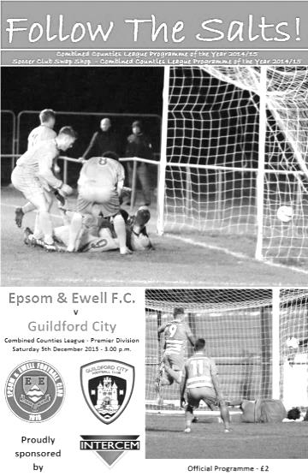
Epsom and Ewell's previous home fixture consisted of a spectacular 5-0 defeat of Hanworth Villa. On Saturday we continued our home form to sink Guildford City 4-0, with an equally tremendous display; despite James Taylor's injury (that he picked up on Saturday 28th) adding to the ever-growing list that consists of key figures including club captain - Sam Currie.

Epsom's strength in depth was tested as Daryl Cooper-Smith was also absent due to suspension, Tom Neale inherited his vacant number 10 shirt and certainly did it justice, adding a goal to his name. Carl Downs had come back into the side's midfield while Michael Eacott returned in goal after having work commitments last Saturday.

The home side began the encounter as they intended to go on, playing with composure and an eagerness to get numbers forward. Initially, the power of Guildford's Connor French, combined with the speed of Adam Nditi, made it extremely difficult for the home side to settle into the game - our attempts were further inhibited by the strong winds that acted as a 12th man for the away side, battling against any attempted clearance from Epsom.

In the opening minutes, Neale displayed his searing pace down the left flank but took an accidental touch with his left foot that disrupted his shot selection at the critical point, sending the effort wide. However, our boys broke the deadlock in the 8th minute. Neale finished off an excellent team goal that was expertly executed: McKay looped a ball towards the back post which was headed across the goal by Kyle Hough before Neale got to the ball first (a sight that became familiar over the course of the match) and applied the finishing touch. In the immediate moments following this, Epsom managed to retain the lead largely from the mistakes of Guildford when attacking, rather than their own defending prowess.

Hough mirrored Neale's effort up front, nearly running clear of the defence that was split by a pinpoint pass from Rhys North in the 15th minute. Unfortunately, the ball got caught up in Hough's feet, rendering him unable to release a shot. Chances then began arising thick and fast, as captain Matt Farrell's acrobatics forced a save from Liam Beach. The speed of the number 10's on both sides was evident early on, North managed to nullify Nditi well, but Neale caused chaos amongst the yellow defence and was cynically brought down in the 17th minute, which left him hobbling back into the box to compete for the resulting free kick.

The Salts second goal came in the 19th minute through Farrell. The eventual goal scorer began the attack, winning the second header in the middle of the park and knocked the ball

forwards to Neale who utilised his speed to worry the defence and draw bodies towards him, leaving Farrell free (inside the box) to tuck Neale's ball into the roof of the net. We showed the reasons for our superior league position as we seemed to dominate all areas of the pitch, building from a stable back four and efficiently progressing up the field of play. This progression usually came from the danger posed on both wings by the tricky Matt Ferdinando on the left and the combination of Tom Neale and Reisse Griffin on the right.

Guildford's first genuine opportunity was squandered in the 33rd minute by a strong save by Eacott that palmed the swerving shot over the bar, this allowed Epsom to demonstrate their uncanny ability to craft defence into attack as we responded with a 35th minute goal, which came about as a result of Griffin's persistence on the right as he glided down the wing before bending a delicious cross into the box that was skilfully volleyed in at full stretch by a sliding Kyle Hough - beyond the reach of Beach in the Guildford goal. Our boys always seemed to have numbers in the box, awaiting the inevitable probing balls from the midfield maestros, unlike Guildford, who often appeared to only have the isolated Nditi as their attacking option.

As the first half drew to a close, we maintained our intensity. and were rewarded in the 43rd minute as a looping free kick was delivered by Ferdinando and headed back across the goal by Craig Hastings (in a similar fashion to the first goal), on this occasion, scored by Hough, allowing the Salts to take a 4-0 lead into the second half.

As the second half commenced, many were keen to make their mark on the game, Matt Tanton for example, began sending balls forward into space for our strikers to run on to, however, on this occasion none resulted in goals. Both sides managed to maintain their shape and discipline for the first 10 minute period of the new half, with free kicks only being conceded within the opposition's half. Tanton dispossessed French as the Guildford man prepared to embark on one of his destructive runs into our defence. As a result, he ended up requiring treatment on his neck.

As the hour mark approached, play began to disintegrate largely due to the windy conditions. For Guildford Nathan Chambers was booked for repeated late tackles. On offensive ventures, we weren't as clinical as we had been in the first half, although we protected our four goal lead fairly comfortably, and our organisation at the back was commendable throughout under the instruction of Eacott and McKay; this formed the spine of the team and allowed the forwards to flourish. Our unbreachable home defence frustrated the away side, as evidenced by Nditi's yellow card for dissent in the 89th minute.

Guildford seemed to produce panicked responses whenever they obtained possession as the clock ticked on and the pressure built, in stark contrast to the confident performance that Epsom were displaying. Credit to both sides for competing until the final whistle, Guildford's Nditi struck the woodwork in the 85th minute from a set piece that left Eacott rooted to the ground and relieved to hear it ricochet off of the bar to safety, Hastings followed suit for our boys with the final kick of the game, but in reality this match was all over by half time and everyone knew it.

Team: Michael Eacott, Rhys North, Matt Tanton, Craig Hastings, Alex McKay, Carl Downs, Reisse Griffin, Matt Farrell (C), Kyle Hough, Tom Neale, Matt Ferdinando.

Subs: Rob Hendry for Hough (53), Steve Rowe for Downs (60)
Beckett Oliver for Grifffin (81)

Club Records - 8th December
Date | Day | Competition |  | Opponents |  | Scorers
08/12/28 | Sat | Friendly | A | Egham | 4-1 | J.Parr, T.Hill, W.Challis (2)
08/12/45 | Sat | London Senior Cup 2 | A | Walton & Hersham | 1-9 | G.Brogdale
08/12/51 | Sat | Surrey Senior Cup 3q replay | A | Surbiton Town | 4-3 | T.Wright (2), B.Goddard (2)
08/12/56 | Sat | Corinthian League | A | Worthing | 1-0 | J.Bangs
08/12/62 | Sat | Corinthian League | H | Eastbourne | 1-3 | E.Arnall
08/12/73 | Sat | Surrey Senior League | A | BAC Weybridge | 2-0 | T.Tuite, D.Ritman
08/12/79 | Sat | London Senior Cup 3q | H | Haringey Borough | 2-1 | F.Samoth, J.Hunn
08/12/84 | Sat | Isthmian League  Premier Division | A | Hendon | 2-1 | S.Milton (pen), S.Hill
08/12/87 | Tue | Isthmian League 2s | A | Egham Town | 1-2 | B.Perkins
08/12/90 | Sat | Isthmian League 2s | A | Southall | 1-1 | S.Barwick
08/12/98 | Tue | Isthmian League 3 | H | Ware | 1-2 | S.Grant
08/12/01 | Sat | Isthmian League 3 | A | Wingate & Finchley | 2-0 | S.Huckle, B.Stevens
08/12/09 | Tue | Surrey Senior Cup 2 | H | Chertsey Town | 3-0 | M.Jarman, K.Hough (pen), R.Burns
08/12/12 | Sat | Combined Counties  Premier Division | A | Hartley Wintney | 4-0 | R.Burns (3), B.Hayward
Historical Decades
Date | Day | Competition |  | Opponents |  | Scorers
90 years ago – Epsom Town F.C.
12/12/25 | Sat | East Surrey Hospital Cup SF | H | Redhill | 2-8 | R.Marlow, J.Parr
80 years ago – Epsom F.C.
07/12/35 | Sat | Friendly | H | London University | 2-2 | B.Neal, H.Pullen
70 years ago – Epsom F.C.
08/12/45 | Sat | London Senior Cup 2 | A | Walton & Hersham | 1-9 | G.Brogdale
60 years ago – Epsom F.C.
10/12/55 | Sat | Surrey Senior Cup 1 | A | Banstead Athletic | 3-2 | B.Blazey, T.Murphy, R.Webb
50 years ago – Epsom & Ewell F.C.
11/12/65 | Sat | Surrey Senior Cup 3q | A | Malden Town | 2-3 | F.Fondyke, T.Thomas
40 years ago – Epsom & Ewell F.C.
06/12/75 | Sat | Athenian League 2 | H | Faversham Town | 3-0 | B.Denman, T.Coombe, o.g.
30 years ago – Epsom & Ewell F.C.
07/12/85 | Sat | Isthmian League  Premier Division | H | Croydon | 1-2 | R.Lewis
20 years ago – Epsom & Ewell F.C.
02/12/95 | Sat | Isthmian League 3 | A | Hornchurch | 1-0 | S.Smith
10 years ago – Epsom & Ewell F.C.
10/12/05 | Sat | Isthmian League 2 | H | Edgware Town | 0-1

History Corner - 8th December
64 years ago today we travelled to Riverhill in Worcester Park Road for a Surrey Senior Cup replay with Surbiton Town. Two weeks previously we had struggled to draw 3-3 with the Surrey Senior League team at West Street in a match that was abandoned for bad light in extra time.

This match was very similar with even the same scorers, Tommy Wright and Bill Goddard. The difference this time was that Goddard scored a second goal as we won 4-3. We had been level at 1-1 at half time but appeared to have done the hard work as we went 3-1 up. However, the homesters had other ideas and pulled it back to 3-3 before we scored a late winner six minutes from time. The local papers weren’t impressed though and said that the only thing that shone in the match was the new white football that was being used!

The Riverhill ground at Surbiton Town was at 90 degrees to the pitches where we played some of our recent pre-season friendlies, but much of it is now covered by the racing track that is to the side of them. The old ground existed until the mid-nineties before it went, although Surbiton Town’s existence as a Senior status club didn’t last beyond the end of the fifties.

60 years ago this week we made our first ever visit to Banstead Athletic’s Merland Rise ground for a Surrey Senior Cup tie. Banstead were regular Champions of the Surrey Senior League around that time with great strikers like Harry Clark and then Norman Dearlove scoring 100 goals a season from about only 30-35 fixtures in those days. However, we weren’t bad ourselves under the new Management of former Kingstonian legend Doug Whitehead and we had some decent players in our team like Dave Hermitage and Ted Murphy. Hermitage had a successful career at Sutton United, eventually becoming their Secretary and then Chairman.

Murphy, who scored in this match from 30 yards as we won 3-2 would arguably have a greater career, that was famous for to things in particular. In 1963 he would become an Amateur Cup winner with Wimbledon, ironically defeating Hermitage and his Sutton United side 4-2 at Wembley Stadium. Even more famously though, whilst with Tooting & Mitcham United he scored at both ends in an F.A. Cup Third Round tie against the mighty Nottingham Forest in 1959. The match ended 2-2 and the Terrors lost the replay but Forest actually went on to lift the F.A. Cup that year! Another great player that just slipped through our fingers!

6 years ago today we hosted Chertsey Town at Merland Rise in a Surrey Senior Cup match, winning 3-0. Both sides had just won F.A. Vase matches three days previously to reach the last 32 but they were no match for us and we sailed through to a home tie with Walton & Hersham that would be remembered for a disastrous collapse, but more of that in months to come.

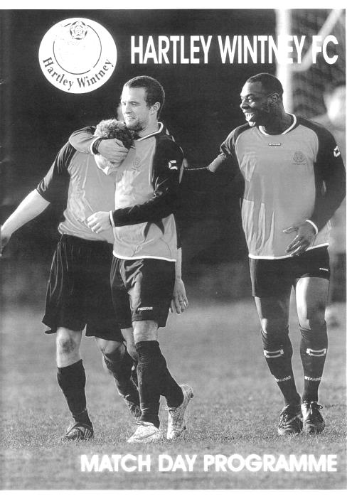
3 years ago today we visited Green Lane for a League match with Hartley Wintney. They were struggling a little in the table, although played well against us and it was even for seventy minutes. Enter substitute Robbie Burns who scored three times to go with another from Ben Hayward to produce a flattering 4-0 score line. Robbie became the first and only substitute to ever score a hat trick for us. (see programme)

CCL Premier Division Club Directory
A.F.C. HAYES Telephone: 0208-845-0110 - Ground: Farm Park, Kingshill Avenue, Hayes, Middx. UB4 8DD - Colours: Blue and White Stripes/Blue/Blue

ASHFORD TOWN (Mx) Telephone: 01784-245908 - Ground: The Robert Parker Stadium, Short Lane, Stanwell, Middx. TW19 7BH - Colours: Tangerine & White Stripes/Black/Tangerine

BADSHOT LEA Telephone: 01252-320385 - Ground: Ash United FC, Shawfield Stadium, Youngs Drive, Shawfields Road, Ash, Hampshire. GU12 6RE - Colours: Claret/White/Claret

BEDFONT SPORTS Telephone: 0208-831-9067 - Ground: Bedfont Sports Club, Hatton Road, Bedfont, Middx TW14 8JA - Colours: Red & Black Hoops/Black/Red & Black Hoops

CAMBERLEY TOWN Telephone: 01276-65392 - Ground: Krooner Park, Wilton Road, Camberley, Surrey. GU15 2QW - Colours: Red & White Stripes/Blue/Red

CHERTSEY TOWN Telephone: 01932-561774 - Ground: Alwyns Lane, Chertsey, Surrey. KT16 9DW - Colours: Royal Blue & White Stripes/Royal Blue/Royal Blue

CHESSINGTON & HOOK UNITED Telephone: 01372-602263 - Ground: Chalky Lane, Chessington, Surrey. KT9 2NF - Colours: Blue/Blue/Blue

COLLIERS WOOD UNITED Telephone: 0208-942 8062 - Ground: Wibbandune Sports Ground, Robin Hood Way, Wimbledon. SW20 0AA - Colours: Blue & Black Stripes/Black/Black

COVE Telephone: 01252-543615 - Ground: Oak Farm Fields, 7 Squirrel Lane, Cove, Farnborough, Hampshire. GU14 8PB - Colours: Yellow/Black/Yellow

EPSOM & EWELL Telephone: 01737-553250 - Ground: Chipstead FC, High Road, Chipstead, Surrey. CR5 3SF - Colours: Royal Blue & White Hoops/Royal Blue/Royal Blue & White Hoops

FARNHAM TOWN Telephone: 01252-715305 Ground: Memorial Ground, Babbs Mead, West Street, Farnham, Surrey. GU9 7DY Colours: - Claret & Sky Blue /White/ Claret & Sky Blue

GUILDFORD CITY Telephone: 01483-443322 - Ground: The Spectrum, Parkway, Guildford, Surrey. GU1 1UP - Colours: Red & White Stripes/Black/Black

HANWORTH VILLA Telephone: 0208-831-9391 - Ground: Rectory Meadows, Park Road, off Hounslow Road, Hanworth, Middlesex. TW13 6PN - Colours: Red & White Stripes/Black/Black

HARTLEY WINTNEY Telephone: 01252-843586 - Ground: Memorial Playing Fields, Green Lane, Hartley Wintney, Hants RG27 8DL - Colours: Orange & Black/ Orange /Orange

HORLEY TOWN Telephone: 01293-822000 - Ground: The New Defence, Anderson Way, Court Lodge Road, Horley, Surrey. RH6 8SP - Colours: Claret & Sky Blue/Claret/Claret

KNAPHILL Telephone: 01483-475150 - Ground: Brookwood Country Park, Redding Way, Lower Guildford Road, Knaphill, Surrey. GU21 2AY - Colours: Red/Black/Red

SUTTON COMMON ROVERS Telephone: 01932-866386 - Ground: Sutton United FC, Gander Green Lane, Sutton, Surrey SM1 2EY - Colours: Yellow/Black/Black

RAYNES PARK VALE Telephone: 020-8540-8843 - Ground: Prince Georges Playing Field, Grand Drive, Raynes Park, London. SW20 9NB - Colours: Blue/Blue/Red

REDHILL Telephone: 01737-762129 - Ground: Kiln Brow, Three Arch Road, Redhill, Surrey RH1 5AG - Colours: Red and White Stripes/Black/Red

SPELTHORNE SPORTS Telephone: 01932-961055 - Ground: Spelthorne Sports Club, 296 Staines Road, Ashford Common, Ashford, Middx. TW15 1RY - Colours: Light & Dark Blue/Dark Blue/Light Blue

WESTFIELD Telephone: 01483-771106 - Ground: Woking Park, Kingfield Road, Woking, Surrey. GU22 9BA - Colours: Yellow/Black/Black

WINDSOR Telephone: 01753-860656 - Ground: Stag Meadow, St Leonards Road, Windsor, Berks SL4 3DR - Colours: Red/Red/Red

EL Records Premier Challenge Cup
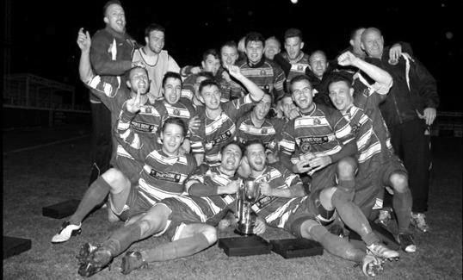
Second Round
Dorking Wanderers | 2-1 | South Park Reserves
Westfield | 1-0 | CB Hounslow United
Bedfont & Feltham | 1-5 | Colliers Wood United
Dorking | 0-3 | Knaphill
Badshot Lea | 2-4 | Spelthorne Sports
Hanworth Villa | 1-2+ | Chertsey Town
Ashford Town (Mx) | 2-1 | Epsom Athletic
Hartley Wintney | 4-2 | Horley Town
Banstead Athletic | 1-1+ | Epsom & Ewell
Epsom & Ewell won 7-6 on penalties
Sheerwater | 3-3+ | Frimley Green
Frimley Green won 8-7 on penalties
Farnham Town | 3-2 | Abbey Rangers
Camberley Town | 4-2 | Eversley & California
AFC Hayes | 0-1 | Banstead Athletic
Redhill | 3-0 | Sutton Common Rovers
Worcester Park | 1-5 | Chessington & Hook United
Cove | 1-6 | Cobham
Third Round
Camberley Town | 15/12 | Spelthorne Sports
Cobham | 15/12 | Frimley Green
Redhill | 15/12 | Farnham Town
Raynes Park Vale | 15/12 | Westfield
Epsom & Ewell | 12/1 | Ashford Town (Mx)
Colliers Wood United | 16/12 | Dorking Wanderers Reserves
Knaphill | 15/12 | Chertsey Town
Hartley Wintney | 15/12 | Chessington & Hook United

Centre page for results

Centre page for results

Cove F.C. – History
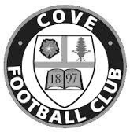
Cove F.C. were formed in 1897 by a group of local people playing on a field behind their favourite Public House.

Moving to a more central location, Cove Green became their home until 1973, when they moved to their present ground at Oak Farm. Playing their football in The Surrey Leagues, Cove enjoyed success for many years, winning more than their fair share of silverware in this time, including the League Championship three years in succession and a double.

In 1973, the club decided to upgrade and were accepted into the Hampshire Leagues, but had to leave 'The Green' for safety reasons. The Division 4 Championship was won at the first attempt, and the Division 3 title followed 2 years later. After a couple of seasons, Cove finished Runners-Up in Division 2, but decided to withdraw from this league due to the time taken to away matches in Portsmouth or Southampton, before the M3 motorway was built.

Thus they returned to the more local Combined Counties League in 1980, and won the League Cup beating close neighbours and rivals Ash United. Since moving into their new home, many changes have taken place at Oak Farm with the installation of floodlights a concrete perimeter wall and stand in their quest to house senior non-league football. These achievements are the more remarkable with Farnborough Town (then Conference League) and Aldershot Town (then Football League) just a couple of miles down the road.

In 1990, Cove were given the chance to join the Vauxhall League (now Ryman League) after finishing third. New manager ‘Chick’ Botley assembled a squad strong enough to finish a respectable fourth in their first season. Two more successful seasons followed narrowly missing out on promotion, once a final day defeat by the new Aldershot Town. Due to the ever spiralling cost of football at this level, Cove were forced to withdraw and had to revert back into The Combined Counties League, where they remained with little success.

After finishing bottom of the league two years running, Cove Football Club appointed Steve Beeks, a young man with no managerial experience, but a good playing record which included a period as professional at Aldershot until their demise in 1990. Within 12 months Cove were on their way back, having regained some respect among the local clubs, and were no longer the ‘Whipping Boys’ finishing a creditable 8th., allowing entry back into the top competitions.

Season 2000-2001 saw Cove reach the 5th round of the F.A. Vase beating some more senior clubs along the way, before losing out to Chippenham Town, and a F.A.Cup victory at Ryman Division One side Bognor Regis. The Premier Challenge Cup was won 3-0 over Walton Casuals and was soon followed by the victory over closest rivals, AFC

Wallingford, that ensured the League Championship, breaking all league records on the way, which included reaching the magic 200 goals scored in all competitions to complete a memorable season.

With the departure of Steve Beeks, the club suffered many traumatic years as different managers tried to lift the club back to the dizzy heights of the late 1990’s but with little success. In 2009 the club appointed Koo Dumbuya as manager and a member of the Steve Beeks double winning team and well known around the area. Having played professional football for Aldershot and Brentford, the club decided his playing experience and knowledge could be invaluable and in his first season won the Southern Combination Cup 4-0 over Chessington and Hook.

In 2010 Cove won the Combined Counties League Cup with a 2-0 win over Bedfont, followed by a victory over Farnborough Town in the semi-final of the Aldershot Senior Cup before losing to Fleet Town in the final.

In 2011 manager Koo Dumbuya left the club after 4 years as player and manager to take up a post at Chertsey Town, leaving a big hole to fill as his knowledge of local football is immense. The task of filling this hole was left to his assistants Paul Duncan and Simon Brand to rebuild the team from new as 9 players left at the end of the previous season. On a happier note, President and old player, Frank Kenton, and Secretary Graham Brown both received an award from Hampshire FA for 25 years service.

During season 2012/13 following some poor performances, the club employed Dan Reeves and old player Anthony Millerick which brought instant success with the winning of the Aldershot Senior Cup and a 3-0 victory over Fleet Spurs, also finishing 3rd in the League, our highest position for many a year. 2013-2014 was another successful season finishing 5th after a run of 22 games, 19 wins and 1 defeat.

2014/15 was a very successful year sitting on top of the league for half the season, but unable to go for promotion due to the cost of ground improvements and travel, saw a considerable dip in form leading to a fifth place finish and a mass exodus of management and players.

A complete change of personnel followed with the appointment of Dave Matthews as manager, following his success as Youth Team coach, accepting the challenge of building a new team capable of retaining their position in the Premier Division.

No resume of Cove F.C. would be complete without mentioning Ron Brown, who in 1990 received an F.A. award for 50 years service to Cove F.C., including 35 years as secretary. Ron retired in 1982 passing the reins to his son Graham who has himself completed 28 years in the job. Sadly Ron passed away in 2009 after 70 years service including 20 years as Club President. On a happier note, President and old player, Frank Kenton, and Secretary Graham Brown were both to receive an award from Hampshire FA for 25 years’ service.

Surrey Senior Cup
Our successful Surrey Senior Cup winning team from 1981
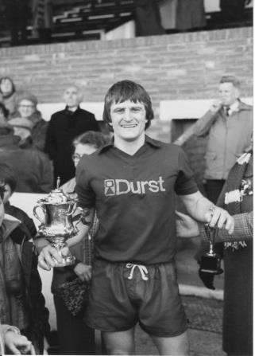
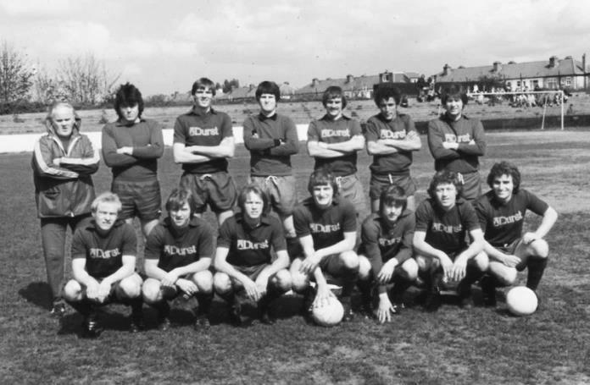
First Round
Ashford Town (Mx) | 3-1 | Beckenham Town
Camberley Town | 1-1 | Knaphill
Knaphill won 3-2 on penalties
Epsom & Ewell | 1-6 | Dorking Wanderers
Second Round
Knaphill | 4-3 | Ashford Town (Mx)
Chipstead | 4-1 | Chessington & Hook United
Colliers Wood United | 1-3 | Whyteleafe
Corinthian Casuals | 1-1 | Egham Town
Corinthian Casuals won 4-2 on penalties
Croydon | 3-3 | Farnham Town
Farnham Town won 3-2 on penalties
Godalming Town | 1-0 | Guildford City
Horley Town | 2-2 | Badshot Lea
Badshot Lea won 4-3 on penalties
Leatherhead | 3-0 | Carshalton Athletic
Merstham | 3-0 | South Park
Met Police | 3-2 | Dorking Wanderers
Molesey | 2-1 | Raynes Park Vale
Redhill | 0-3 | Tooting & Mitcham United
Sutton United | 3-0 | Walton & Hersham
Walton Casuals | 1-1 | Kingstonian
Kingstonian won 9-8 on penalties
Westfield | 2-0 | Chertsey Town
Woking | 10-0 | Sutton Common Rovers

F.A. Vase
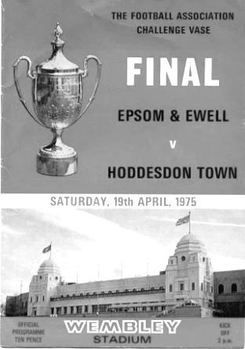
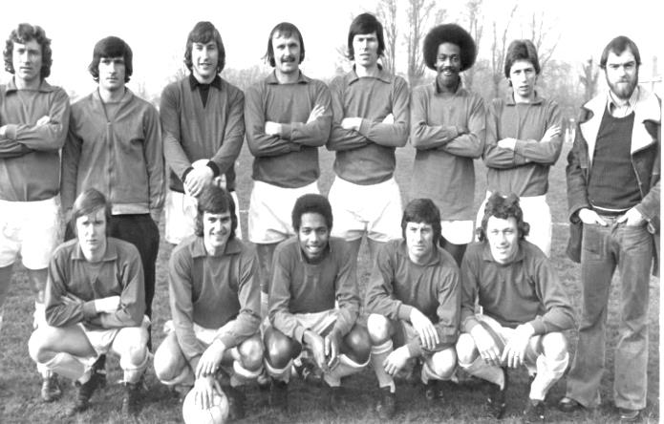
Third Round – 12th December
Marske United | V | Team Northumbria
Sunderland RCA | V | Tadcaster Albion
Newton Aycliffe | V | Atherton Collieries
South Shields | V | Morpeth Town
North Shields | V | Runcorn Town
Dunston UTS | V | Seaham Red Star
Alsager Town | V | AFC Wulfrunians
St Andrews | V | Leicester Nirvana
Handsworth Parramore | V | Cleethorpes Town
Pinxton | V | Nuneaton Griff
Walsall Wood | V | Alvechurch
Uttoxeter Town | V | Coleshill Town
Hereford | V | Brocton
Saffron Walden Town | V | Berkhamsted
FC Broxbourne Borough | V | Bowers & Pitsea
Hullbridge Sports | V | Stanway Rovers
AFC Dunstable | V | Basildon United
Edgware Town | V | Ipswich Wanderers
Yaxley | V | Sleaford Town
Hertford Town | V | FC Romania
Colliers Wood United | V | Hartley Wintney
Thame United | V | Kidlington
Ascot United | V | Camberley Town
Lordswood | V | Ashford United
Eastbourne Town | V | Sutton Common Rovers
Tadley Calleva | V | Newport (IW)
Canterbury City | V | Knaphill
Moneyfields | V | Brimscombe & Thrupp
Buckland Athletic | V | Bradford Town
Highworth Town | V | Salisbury
Welton Rovers | V | Bodmin Town
Bristol Manor Farm | V | Hengrove Athletic

Player Sponsorship
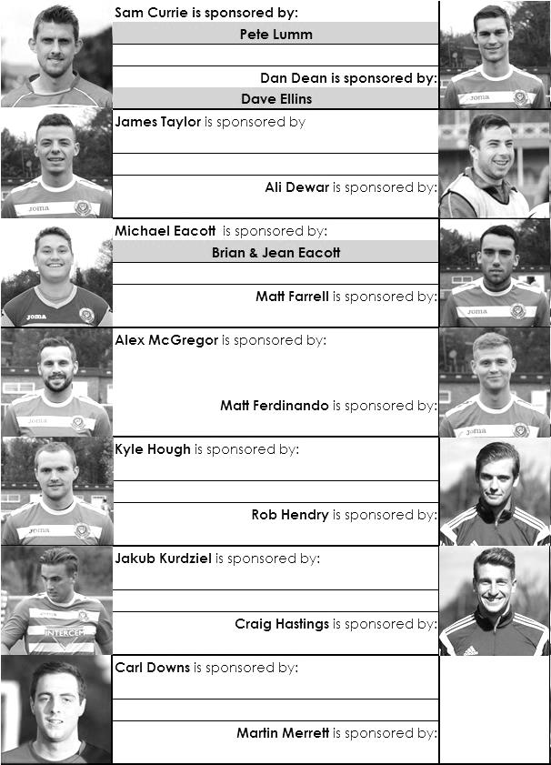

Here is the current list for the 2015/16 season showing all of our players and Management that are currently available for sponsorship this season.

Sponsorship costs just £40 and it is easy to do. Just select a player who has not been previously sponsored and let a Committee Member know that you would like to sponsor them. Beware though. Until we have received the money it is possible for someone to jump in front of you, so don’t delay, sponsor today!

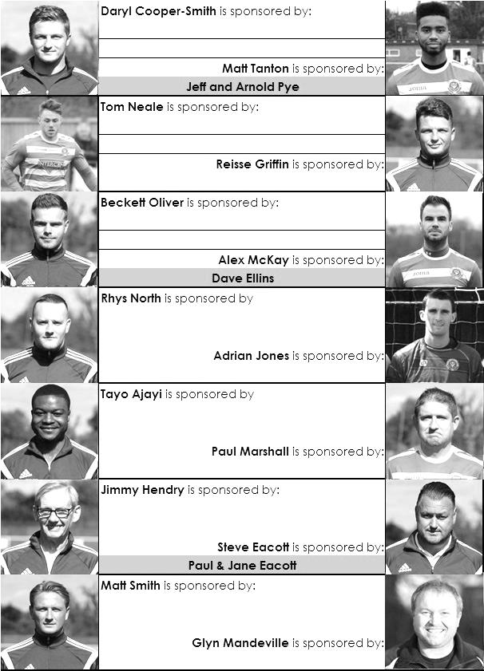

Match and Ball Sponsorships – 2015/16
Opponent | Date | Match and Match Ball Sponsor
Hoddesdon Town | 18/07/15 | Geoff Dyke
Windsor | 08/08/15 | Club President Stella Lamont
Erith & Belvedere (FAC) | 16/08/15 | Mike Lovett
Raynes Park Vale | 31/08/15 | EEFC Management Committee
Colliers Wood United | 08/09/15 | Bookham Building Shop – www.buildingshop.co.uk
AFC Hayes | 19/09/15 | John Bonner
Farnham Town | 26/09/15 | Ezara and Inaya Beddoe – our youngest supporters!
Chertsey Town | 17/10/15 | Club Media Officer – Richard Lambert
Dorking Wanderers (SSC) | 20/10/15 | Tony Ferdinando
Chessington & Hook United | 07/11/15 | Paul Merritt
Hanworth Villa | 21/11/15 | Maggie Beddoe
Guildford City | 05/12/15 | Pete Lumm
Cove | 08/12/15 | Marvin Hough
Sutton Common Rovers | 19/12/15
Redhill | 02/01/16
Ashford Town (Mx) (LC) | 12/01/16
Spelthorne Sports | 16/01/16
Hartley Wintney | 30/01/16
Bedfont Sports | 13/02/16
Horley Town | 27/02/16
Knaphill | 12/03/16
Westfield | 26/03/16
Badshot Lea | 09/04/16
Camberley Town | 16/04/16
Ashford Town (Mx) | 30/04/16
For League, League Cup and Surrey Senior Cup Matches:
Match sponsorship - £40.00 Match ball sponsorship - £25.00. Combined £55.00.
For F.A. Cup and F.A. Vase matches:
Match sponsorship - £50.00 Match ball sponsorship - £30.00. Combined £65.00.

Sponsorship includes: (x2 for match, x3 for match and ball)

Admission, programmes, hospitality and advertising and mascot for the day (if required).
If you are interested, just speak to a Committee Member, or drop me an email at: richard.c.lambert@gmail.com

We also thank our Kit Sponsors INTERCEM

Salts Super Six Predictor
The Salts Super Six Predictor Competition is live again and the tickets are on sale at today’s game to the left of the gate. We recently had our second winner when Maggie Beddoe selected all six results correctly but the jackpot is already beginning to rise.

The competition is easy to play! To win, you simply need to predict the results of the six matches correctly from the three options, fill in the form and make sure it is back with our sellers before the deadline on the ticket.

If you are a club regular, you just need to place your name on the sheet, although if you aren’t, then we’ll need a contact number from you too. We will announce any winners on the website within three working days, so don’t worry we won’t miss you!
The jackpot is now at £117 and who knows how high it could go this time!

Please note that if there is more than one winner, the prize pot would be shared between the winners. All you need to do now is have a go, as many times as you like!

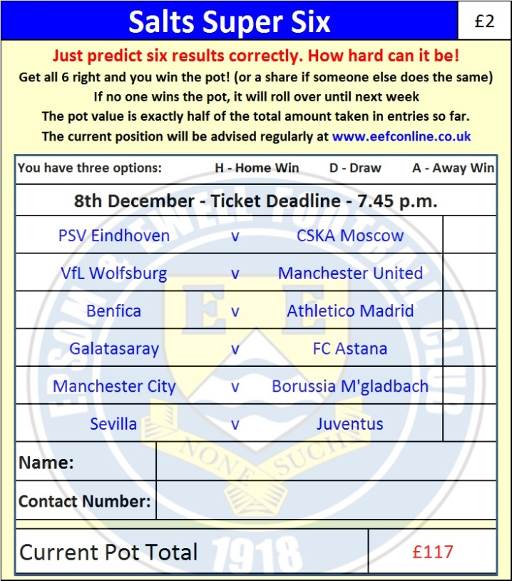

Good luck!

Combined Counties League – Premier Division
Tuesday, 8th December 2015 - Kick-off 7.45 p.m.
Epsom and Ewell  (Royal Blue & White hoops) | V |  | Cove F.C.  (Yellow and Black)
Squad | NUMBERS |  | Squad
Michael Eacott |  |  | Aiden Upward
Rhys North |  |  | Sam Lynam
Steve Rowe |  |  | Jordan Stepney
Craig Hastings |  |  | Jack Howard
Alex McKay |  |  | Michael Flounders
Carl Downs |  |  | Mike Davis
Reisse Griffin |  |  | Josh Kempton
© Matt Farrell |  |  | Drew Matthews
Kyle Hough |  |  | Richie Palmer
Tom Neale |  |  | Jordan Baker
Matt Ferdinando |  |  | Jordan Woodward
James Taylor |  |  | Sam Slater
Beckett Oliver |  |  | Ryan Matthews
Rob Hendry |  |  | William Bidlake
Dan Dean |  |  | Malachi Gayle
Alex McGregor |  |  | Jamie Cunningham
Adrian Jones
Sam Currie
Savvas ‘Agi’ Panayiotou
Tayo Ajayi
Jamie Hatfield
Glyn Mandeville | MANAGER |  | Dave Matthews
Matt Smith | ASSISTANT |  | Stuart Bowman
Steve Eacott / Alex McKay / Jimmy Hendry | COACHES / PHYSIO
REFEREE: M.Hayden (Epsom)
ASSISTANTS: D.Olugunna (Wallington), R.Wells (Coulsdon)
Today’s Match and Match Ball are sponsored by
Marvin Hough, father of our long-serving striker Kyle

OUR NEXT VISITORS TO HIGH ROAD ARE:
Sutton Common Rovers
Saturday 19th December 2015 - Kick-off 3.00 p.m.
Combined Counties League – Premier Division

